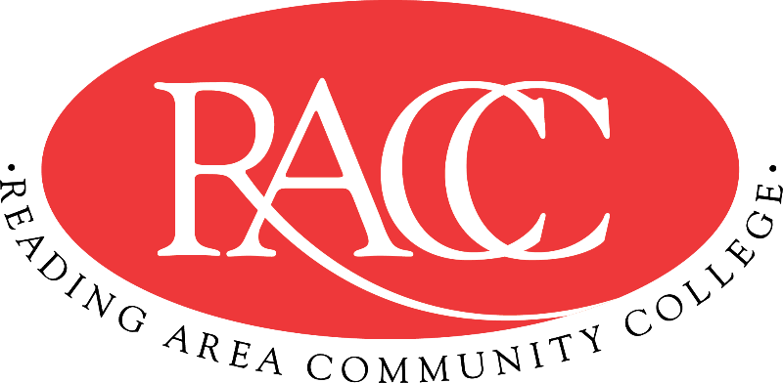

Transfer Guide
Reading Area Community College & Penn State Berks
A.A. in Business Administration |  |  | B.S. in Business
Course | Name | CR | Equivalent Course/ Area Satisfied | CR
CSS 103 | College Success Strategies | 3 | 3 cr. PSU xfrGEN | 3
COM 121 | English Composition I | 3 | ENGL 15 (GWS) | 3
MAT 220 | Calculus I | 3 | MATH 140 (GQ) | 3
IFT 110 | Introduction to Information Technology | 3 | MIS 204 | 3
BUS 100 | Introduction to Business | 3 | BA 100 (GS) | 3
Total Credits |  | 15 | Total Credits | 15
COM 151 | Fundamentals of Speech | 3 | CAS 100 (GWS) | 3
BUS 200 | Macroeconomics | 3 | ECON 104 (GS) | 3
BUS 106  or COM 221 | Business Communication  or English Composition II | 3 | ENGL 202D (GWS)  or ENGL 202B (GWS) | 3
ACC 105 + ACC 110 | Financial Accounting and Managerial Accounting | 3 + 3 | ACCTG 211 + 2 elective credits | 4 + 2
Total Credits |  | 15 | Total Credits | 15
HIS 110 or HIS 115 | History of the United States I or II | 3 | HIST 20 (GH) or HIST 21 (GH) | 3
BUS 230 + PHI 275 | Business Law and Introduction to Ethics | 3 + 3 | BA 243 + PHIL 103 (GH) (by Substitution) | 3 + 3
BUS 201 | Microeconomics | 3 | ECON 102 (GS) | 3
ANT 140 | Cultural Anthropology | 3 | ANTH 45 (GS; US/IL) | 3
Total Credits |  | 15 | Total Credits | 15
ENV 130 | The Environment | 3 | BISC 3 (GN) | 3
MAT 210 | Statistics | 3 | STAT 200 (GQ)  (by Substitution) | 3
Art Elective | See recommended Art courses | 3 | General Education: Art (GA) | 3
Gen. Ed – Natural/Physical Science | See recommended Science courses | 4 | General Education: Natural Sciences (GN) | 4
MGT 100 | Principles of Management | 3 | MGMT 301 | 3
Total Credits |  | 16 | Total Credits | 16
Total Credits |  | 61 | Total Credits Transferable | 61

This Transfer Guide is designed for Penn State Berks ONLY. Students seeking transfer admission to any other campus should contact that campus directly.
This Transfer Guide may change without notice before the student is admitted to Penn State Berks. RACC students should confirm their academic plans with the Transfer Admissions Counselor at Penn State Berks: 610-396-6060 or berkstransfer@psu.edu. Following this Transfer Guide does not guarantee admission or transfer of credit to Penn State Berks.

